Aggregate Drilling Page

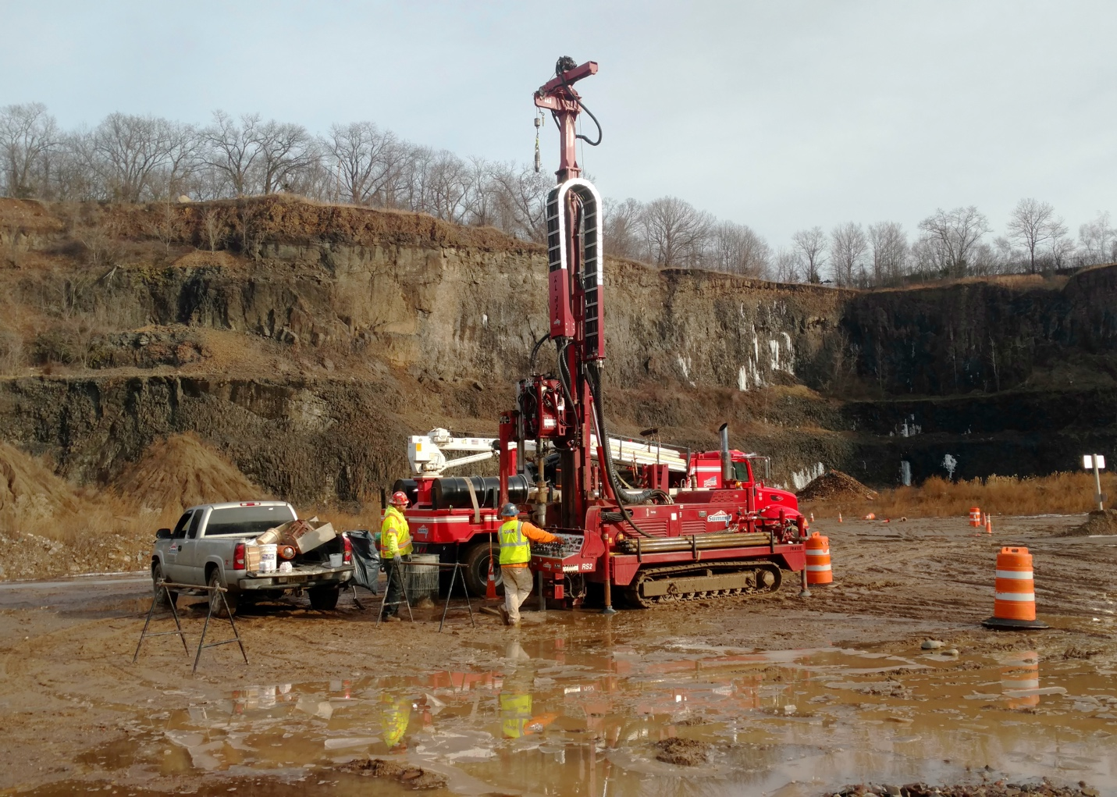

[Icon] INDUSTRIES SERVED
Aggregate Drilling Services
Core insights that drive smarter, more profitable excavations

[Main content well]
From coring accuracy to equipment uptime, Summit provides the data and daily production reliability quarry owners count on to assess reserves, reduce uncertainty, and confidently advance their mining plans.

We supports large quarry and test pit owners with expert coring services. Geotechnical drilling and sampling of aggregate materials such as sand, gravel, and stone determines material location and volume, two critical factors in terms of excavation planning and cost estimating.

Summit provides reliable core sampling that is used to determine the thickness of aggregate beds, as well as the amount of overburden present. Cores can be studied to determine the volume of materials for excavating. At the same time, core samples will help determine the amount of vegetation and topsoil covering the material beds.

To ensure maximum uptime, Summit proactively maintains all equipment through their internal Fleet Maintenance and Management Division. This ensures our field crews can execute targeted amounts of core drilling per day with minimal to no disruption.

If you need a proven team to help you with the assessment and growth of your quarry or sand pit operation, add Summit to your bid list today!

Summit’s Lauren DiVello is a dedicated and experienced customer advocate. Reach Lauren at 609-238-2815 to discuss your project needs. Or email LDivello@SummitDrilling.com and she will reply promptly.

[Stat-a-Project Form]

